Foundation Programs Design
Project: Online Ordering
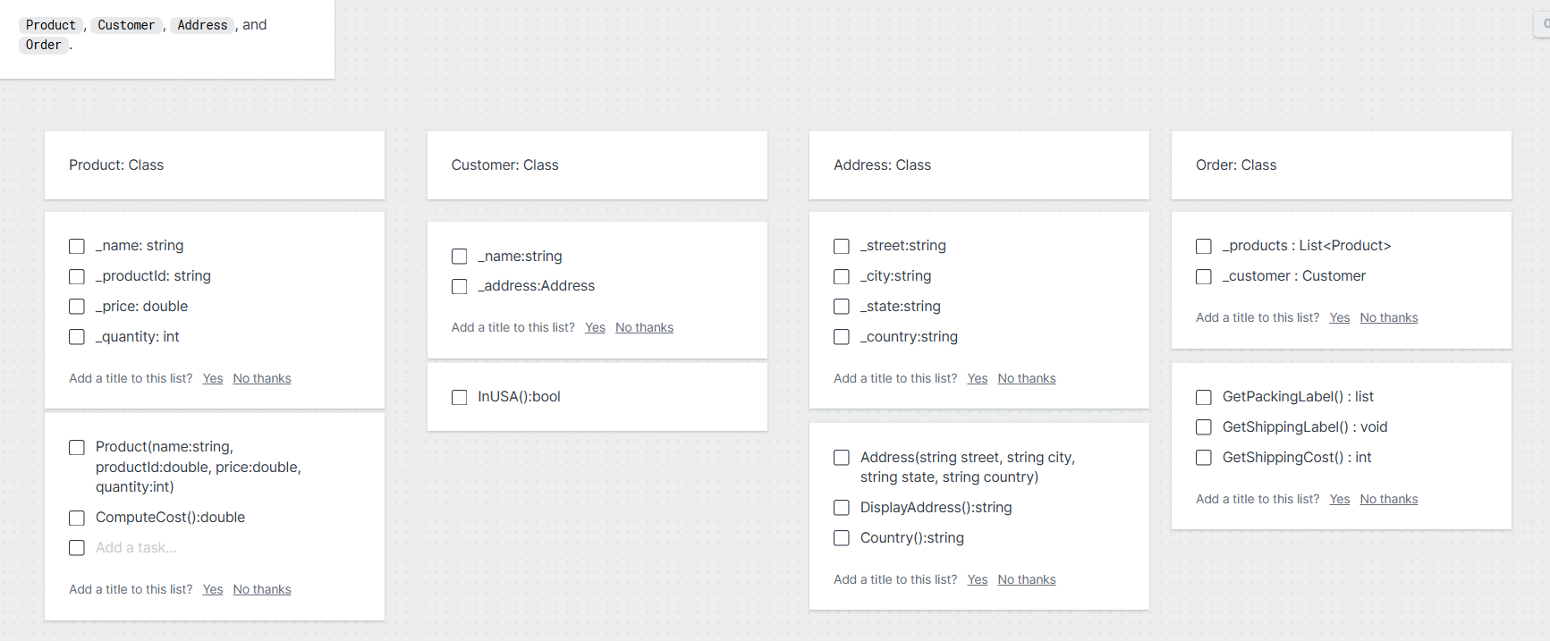

Project: Youtube Videos
